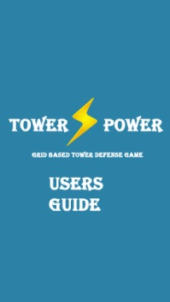

CS319 Fall 2014 Course Project

Tower Power!

User’s Guide

**Group A**

Ahmet Küçük

Serkan Demirci

Özgür Öney

Contents

Copyright 4

Introduction 4

• What is "Tower Defense”? 4

• Tower Power! 4

• Equipment 5

Installation 5

Uninstallation 5

Playing the game Tower Power! 6

Introduction to the game 6

To Change Background Music Volume 7

To Get Help 8

Starting the game 9

Adding & upgrading a tower 10

Further Help 11

# Copyright

Tower Power©, December 2014. The content of this game (such as text, graphics, logos, button icons, images, digital downloads, data compilations and software) is the exclusive property of Bilkent University CS319 Object-Oriented Software Engineering Project Group A and is, unless specifically stated otherwise, protected by copyright, and other intellectual property rights.

It is published by us and may not be reproduced other than by downloading and viewing on a single CPU and/or printing a single hard copy, for private or internal business purposes only. It is not to be otherwise reproduced, transmitted, made available on a network or used to create derivative works without our prior written consent. All rights reserved.

Any infringement of our rights will result in appropriate legal action.

# Introduction

## What is "Tower Defense”?

Tower defense is a kind of strategy game that user tries to stop enemies from crossing a map by building traps to slow them down and towers which shoot at them as they pass. Enemies and towers usually have varied abilities, costs, and upgrade costs. When an enemy wave is defeated, the player earns money or points, which are used to buy or upgrade towers, or upgrade the number of money or points that are earned, or even upgrade the rate at which they upgrade.

## Tower Power!

Tower Power! is a tower defense game. As with all tower defense games, player must defend the enemy units before they reach the town. In order to stop the movement of the enemy units player must,

• Build towers that attack enemy units,

• Put some traps to the path to make enemy units move slower,

• Upgrade towers to make them stronger.

Enemy attacks occur in waves. Enemies get stronger by each wave. While not letting enemies that to pass the path, player also needs to build and upgrade the towers and get ready to the next enemy wave. If a certain number of enemies enter the town game ends and total score of the player is shown.

## Equipment

In order to play the game Tower Power! , a computer is needed, as expected. Game is designed to be built in high percentage of computers existing. Minimum requirements are below.

* CPU: Intel P4/NetBurst architectureor its AMD equivalent (AMD K7)*
* RAM: 256 megabayt
* GPU: GeForce 256 or ATI Rage XL and up**
* HDD: At least 10 MB for game data
* Java SE 6 Update 32 or Java SE 7 Update 4 or newer version.
* 800x600 screen resolution is needed, 1024x768 or more is recommended

*: Any CPU with MMX/SSE instructions **:Any GPU with full OpenGL 1.2 support

# Installation

Tower Power! game is created as a .jar file, which means that you need no installation process to play it. Double clicking on the .jar extension file will redirect you to the playing screen directly and the data that is needed to be stored such as level information or settings are stored in these file itself.

# Uninstallation

In order to delete the content of the game from your computer, a simple deletion is needed. Deleting the .jar extension file from the computer hard disk of the computer is enough to uninstall the game and game data.

# Playing the game Tower Power!

## Introduction to the game

When you get the game data to your hard disk and simply double click on .jar extension file to play the game, Main Menu screen of the game is the screen that you face. Here, you can see Play Game, About, Help, Settings and Exit options. Play Game option directly drive you to the level selection screen and then in game. In Settings option, however, you could change the settings of volume of the game and adjust it into three different levels. In About option, there will be a bunch of information about developers, copyright etc. Help option provides a visual demonstration for the inexperienced users and gives simple notation about how the game is played.

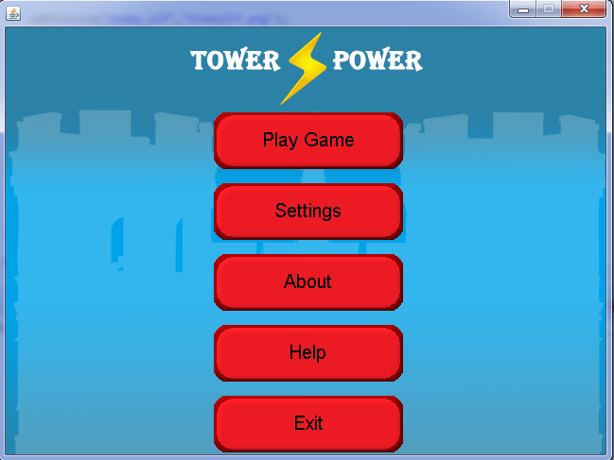

## To Change Background Music Volume

In game, background music is default. In Settings tab at the Main Menu, you could change the volume by clicking on one of options High-Medium-Low. Also, there is a tab for the default audio volume, which positioned between medium and low volume. User could select these option to turn the sound back to its default value. Game simply remembers the preference of the user, which means that the option selected by player for volume will be remembered even player exit the game and open it again.

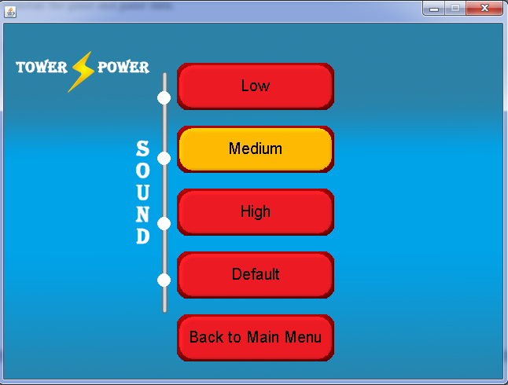

## To Get Help

Users, especially the ones who have no information about tower defense game type, could get information about the game by clicking on the “Help” button in Main Menu. Here, user could see how to play game and get information about game logic as well as entity objects of the game such as castle, path, races and towers. In this menu, gameplay is demonstrated from scratch, images are in order from the very beginning of the game until the end of the game. Player is taught to which parts in the game are enemies, castle and towers; how can he add a tower or upgrade it and what is the term “gold”.

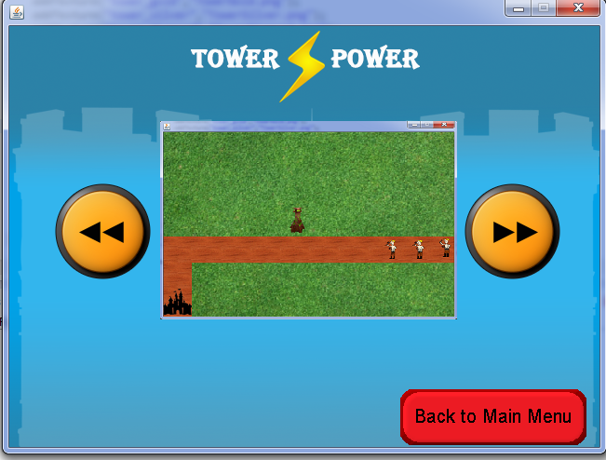

## Starting the game

You could start to play a game by clicking the button “Play Game” in the Main Menu. After that, the game directly starts in level 1. In the very beginning, there is just the Castle of you and the path that enemies will be following. Also, current currency could be shown at the right and top of the in-game screen and so in there player can see how many towers he can add or what the amount of the gold that he has.

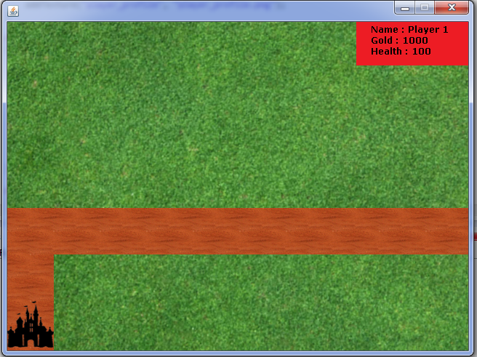

## Adding & upgrading a tower

You can add a tower anywhere on the map as long as clicked place has no other tower, you have not clicked on the path that enemy will be following or you have sufficient gold. When all these conditions satisfied, all you should do to add a tower on the map is clicking. Tower can also be upgraded if you have sufficient money. Towers have 5 different levels:

* Bronze: Lowest range, damage and health point.
* Silver: Has higher specs than bronze tower
* Gold: Has higher specs than silver tower
* Diamond: Has higher specs than diamond tower
* Barad-dûr: Highest in range, damage and health points. Hurts, really…

So, towers are upgraded in this order and to do this, clicking is enough.

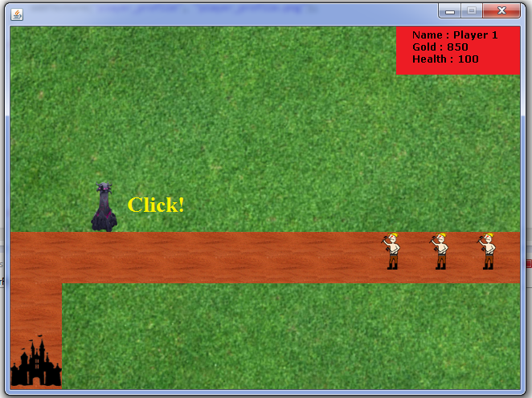

# Further Help

For more information about anything, please contact with the developers of the game. E-mail addresses are provided below.

Serkan Demirci

[serkan.demirci@ug.bilkent.edu.tr](mailto:serkan.demirci@ug.bilkent.edu.tr)

Özgür Öney

[ozgur.oney@ug.bilkent.edu.tr](mailto:ozgur.oney@ug.bilkent.edu.tr)

Ahmet Küçük

[ahmet.kucuk@ug.bilkent.edu.tr](mailto:ahmet.kucuk@ug.bilkent.edu.tr)